FOOD

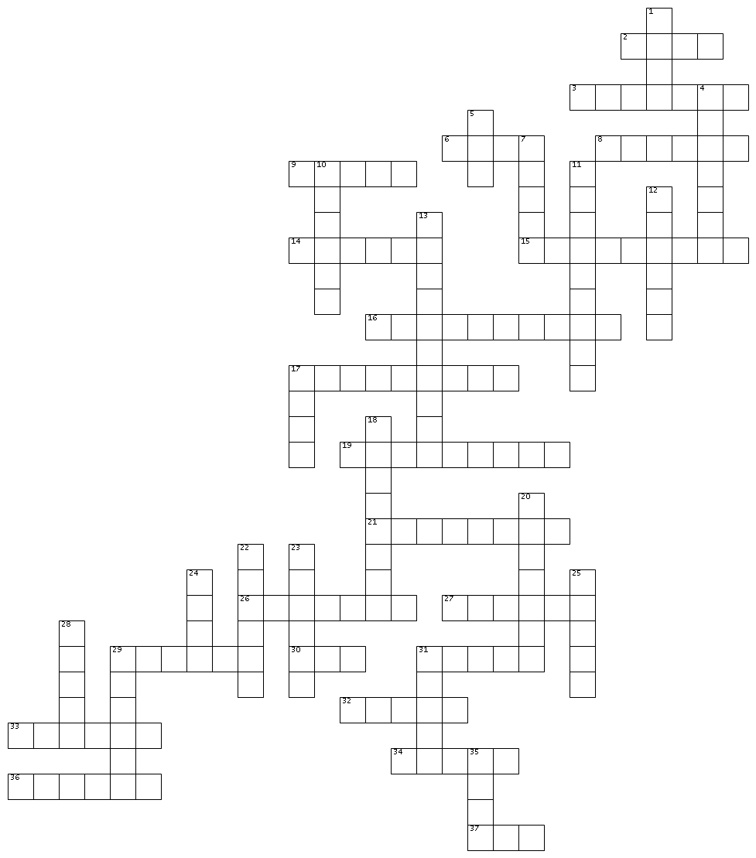

ACROSS → | DOWN ↓
2. It’s a drink, made with gas and a lot of sugar. It’s not healthy and you shouldn’t drink that too much.  3. It’s a green vegetable. It looks like salad but it isn’t salad.  6. It’s white. You can drink it. It’s in the dairy group.  8. It is very soft. It can be sweet , with fruits or fruits flavor. It is cold. It’s in the dairy group.  9. It’s a fruit. It keeps doctors away and it’s the symbol on some computers.  14. It is a yellow and long fruit. Monkeys love it.  15. It’s the first meal of the day, a very important one.  16. It’s a red fruit. It grows in May and June. It’s delicious with whipped cream.  17. They are sort of pasta, long and stringy.  19. It’s a very small fruit that comes from America. You can make a typical sauce with it.  21. They go by two. They are red fruits.  26. It’s a vegetable, symbol of Halloween.  27. It’s yellow. It’s in the dairy group.  29. It’s a typical American biscuit.  30. It’s the favorite drink of the British.  31. It is very sweet, addictive and bad for your teeth.  32. It’s the second meal of the day.  33. It is made of bread, meat, tomato, cheese, onions and salad  34. Milk, cheese and butter are …. products  36. It’s the meal you have in the evening.  37. It’s light brown or white. It has yellow stuff in it. It’s made by hens. | 1. It’s a cereal. British called it maize.  4. You can make flour with them, and then make bread, pasta.  5. It’s a dessert. You usually put fruits on it.  7. It’s a Turkish sandwich.  10. You can make chips and crisps with it.  11. It’s a blue and round fruit. It’s very small.  12. It’s a black and bitter hot drink.  13. It’s a green fruit but it’s red inside. You can eat it in summer.  17. You made this with different vegetables. It’s liquid and hot. It’s very good in Autumn and winter.  18. It’s a green vegetable. It looks like a tree.  20. When something is good for you and your body, you call it …… food.  22. It is green or red. It can be very spicy and hot. It is a vegetable.  23. It is round and red. Some people think It is a vegetable but it is really a fruit. People use it in salad or on pizzas  24. It is sweet and/or has a lot of fat, it can be very tasty but not healthy at all. It is …. Food.  25. It is part of the cereal or grain group. It is made with flour and baked in oven. You can make toasts with it.  28. It’s the most important drink on earth. You can’t live without it.  29. It’s made with milk from cows, sheep or goats. French love it.  31. You need it to make chocolate. It comes from tropical countries.  35. It’s a cereal. It grows in water. Asians eat a lot of it.

