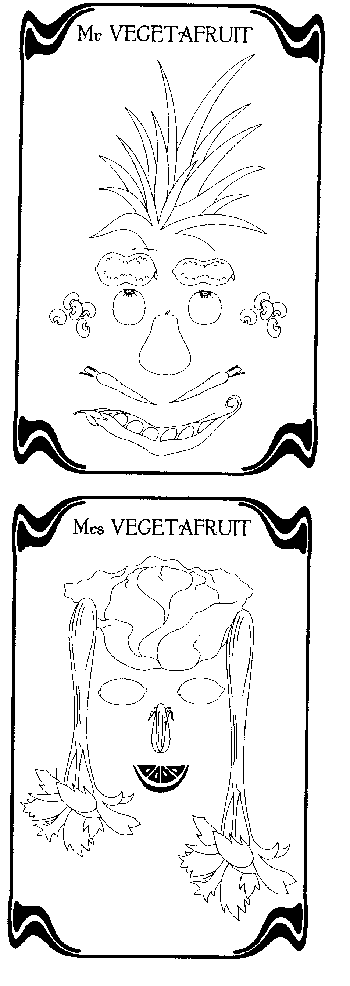

THE PORTRAIT OF Mr VEGETAFRUIT
His nose is a ...........................................and his hair is the top part of a .................... . He is smiling. His mouth is in fact ................................. and his moustache is made up of two.............................. His ears are .............................., his eyes are ........................... and his eyebrows are ............................. .
Help ! Words to insert : GARDEN PEAS / PEANUTS / PINEAPPLE / CARROTS / PEAR / TOMATOES / MUSHROOMS
THE PORTRAIT OF Mrs VEGETAFRUIT
She has a hat made of.................................and her hair is ................................. .Her nose is ...................................... and her mouth is a slice of........................................ Her large eyes are just two................................
Help ! Words to insert : CORN / LEMONS / ORANGE / LETTUCE / CELERY

THE PORTRAIT OF Mr VEGETAFRUIT
His nose is a ...........................................and his hair is the top part of a .................... . He is smiling. His mouth is in fact ................................. and his moustache is made up of two.............................. His ears are .............................., his eyes are ........................... and his eyebrows are ............................. .
Help ! Words to insert : GARDEN PEAS / PEANUTS / PINEAPPLE / CARROTS / PEAR / TOMATOES / MUSHROOMS
THE PORTRAIT OF Mrs VEGETAFRUIT
She has a hat made of.................................and her hair is ................................. .Her nose is ...................................... and her mouth is a slice of........................................ Her large eyes are just two................................
Help ! Words to insert : CORN / LEMONS / ORANGE / LETTUCE / CELERY

